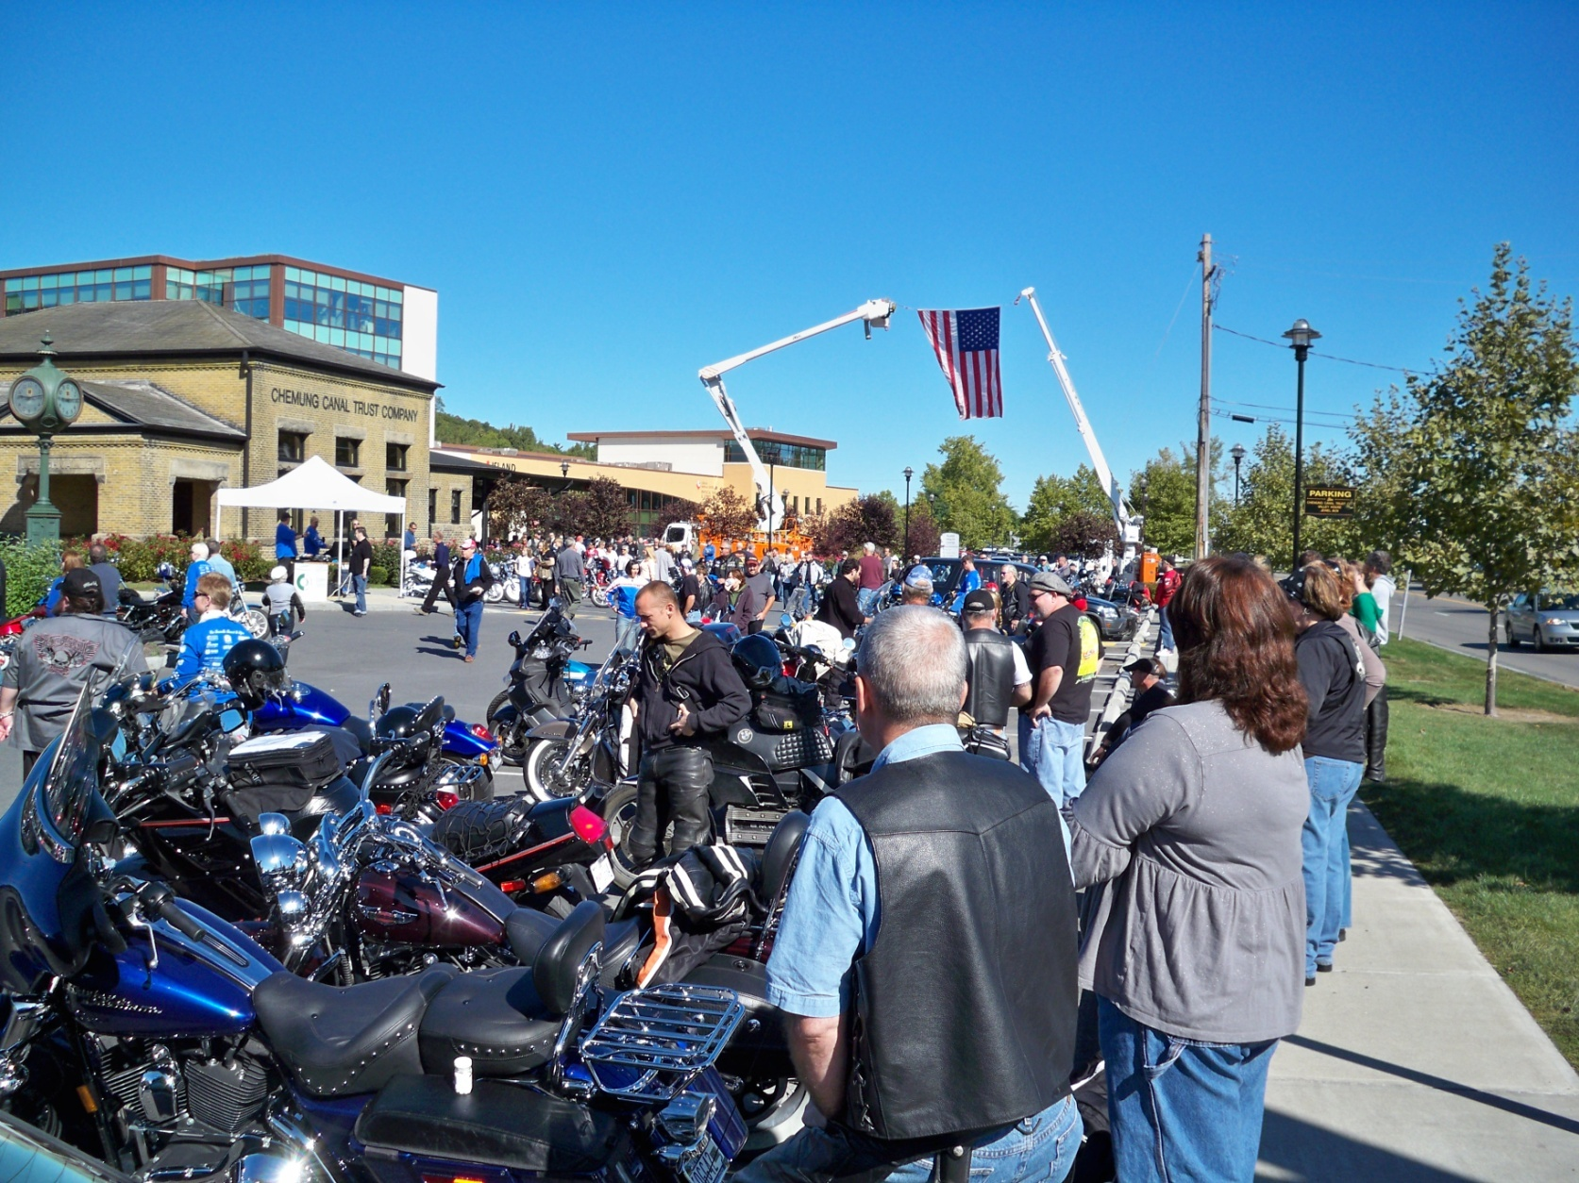
Join us for our 14th annual
Cops, Kids, & Toys
Motorcycle Ride

Sunday, September 22nd

Motorcycle ride around the beautiful Fingerlakes @ 11:30 a.m.

Event begins at the Eagles Club on 161 Cecil Malone Drive, Ithaca, New York
There will be a free continental breakfast or breakfast to purchase
Event ends with a chicken BBQ, raffles and auction at
the Eagles Club on 161 Cecil Malone Drive, Ithaca, New York

Prize Raffle! Balloon pops! 50/50 Raffle!
Pre-Register:
Rider: $20.00 ($15 for a passenger).
We will stop accepting pre-registrations on September 1st.
Shirt: Guaranteed if registered by September 1st.
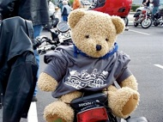
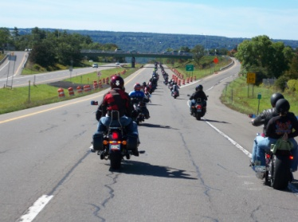
On-site registration:
Rider: $25.00 ($20 for a passenger).
Shirt: Maybe, but you better arrive early!

Please note:
You must pre-register if you would
like a size XXL, or XXXL shirt.

Make a difference in the lives of children!

For more information
email us at:
info@copskidsandtoys.org

Registration forms also available online at:
copskidsandtoys.org

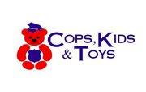

Cops, Kids, & Toys Inc.
836 Hanshaw Road
Ithaca, NY 14850

Find us on Facebook:
Cops, Kids, & Toys
Motorcycle Ride

--------------------------------------------------------------------------------------------------------------------------------
Official Registration:
I would like to (please circle one): Motorcycle Ride / Just Donate

Pre-register by September 1st - Rider: $20.00 ($15 for a passenger)
On-site registration - Rider $25.00 ($20 for a passenger)

Name: ___________________________________________ Address: _______________________________________
City/State/Zip: ___________________________________________ Phone(s): ________________________________

E-mail: ____________________________________ Passenger ____________________________________________

T-shirt size: (circle one) S M L XL XXL XXXL Passenger size: (circle one) S M L XL XXL XXXL

Cash enclosed $___________ Check enclosed $___________ Please make checks payable to Cops, Kids & Toys Inc.

Mail registration form to: Cops, Kids, & Toys Inc. 836 Hanshaw Road, Ithaca, New York 14850

